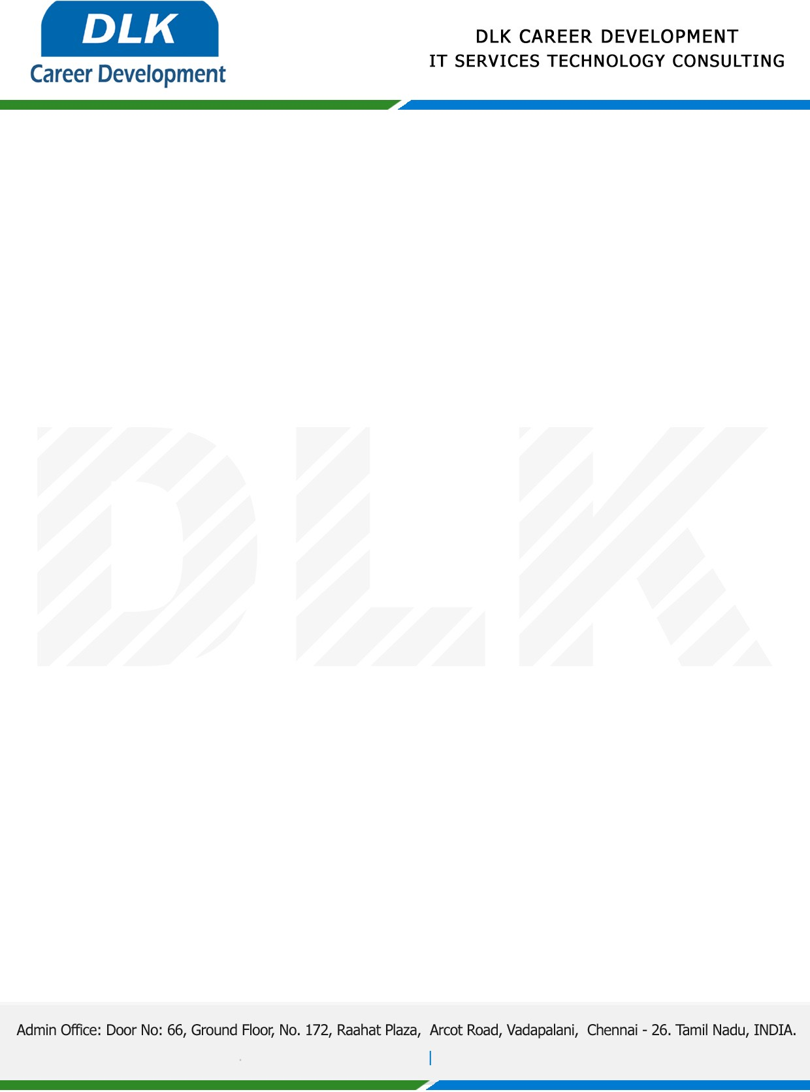

Date: 01 / December/ 2022

**To**

Department of MBA ([General Management),](https://www.cseindia.org/)

Head of Department,

Anna university-Alagappa College of Technology, Chennai - 600025.

**Sub: Letter of Project Acceptance**

This is to certify that **MS HARINI B (REG NO: 68220200017)** that second year student of has accepted her Project Work duration from  **December 2022** to **March 2023** under the domain” **General Management”.** During the Project, all information and data collected from your should be kept confidential.

**Topic:** Analysis of Satisfaction Level of Employees in the Telecom Sector.

We appreciate your interest in **DLK CAREER DEVELOPMENT**

